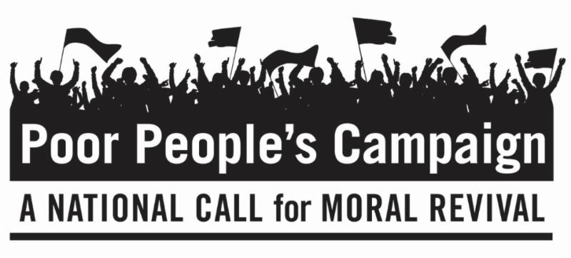
May 28, 2018
Dear Friends,
This is the third of six Mondays of The Poor People's Campaign: A National Call for Moral Revival that began a 40-day campaign on May 14, 2018. On six consecutive Mondays, people of peace are standing up for 12 Fundamental Principles at state capitals throughout the United States, including the country's capital in Washington, D.C. We invite you to be in dialogue with yourself and others about these principles.
Principle 5: We believe that people should not live in or die from poverty in the richest nation ever to exist. Blaming the poor and claiming that the United States does not have an abundance of resources to overcome poverty are false narratives used to perpetuate economic exploitation, exclusion, and deep inequality.
Principle 6: We recognize that the centrality of systemic racism in maintaining economic oppression must be named, detailed and exposed empirically, morally and spiritually. Poverty and economic inequality cannot be understood apart from a society built on white supremacy.
Questions to Consider Personally and/or With Family, Friends and Faith Communities about Principles 5 and 6:
- If I were a person who blamed Poor People for their own circumstances, what would I say about them?
- Describe what makes me comfortable or uncomfortable about white supremacy or privilege.
- If someone is poor and white, do they have white privilege?
- How have I seen systemic racism in society?
If you wish to learn more or become involved in the Poor People’s Campaign, go to https://www.poorpeoplescampaign.org/ or search for Poor Peoples Campaign in your state. Let us know where and how you will participate and send us photos and reflections.
Peacefully,
Rev. Andrea Goodman
President of the Board
with the Executive Director,
The Board of Directors,
The Advisory Board and all of us
at The Interfaith Peace Project

