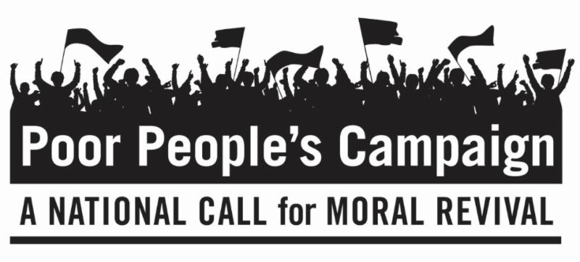

May 21, 2018

Dear Friends,

This is the second of six Mondays of The Poor People's Campaign: A National Call for Moral Revival that began a 40-day campaign on May 14, 2018. On six consecutive Mondays, people of peace are standing up for 12 Fundamental Principles at state capitals throughout the United States, including the country's capital in Washington, D.C. We invite you to be in dialogue with yourself and others about these principles.

Principle 3: We believe in the dismantling of unjust criminalization systems that exploit poor communities and communities of color and the transformation of the “War Economy” into a “Peace Economy” that values all humanity.

Principle 4: We believe that equal protection under the law is non-negotiable.

Questions to Consider Personally and/or With Family, Friends and Faith Communities about Principles 3 and 4:

- What would it mean for society to dismantle unjust criminalization systems? Do I believe it is important to examine who and why people are being imprisoned? What evidence do I have that Poor People of all races are sent to jail more than those in the majority on a higher economic rung?

- Give personal examples of a time when I stood up for equal protection under the law and when I was afraid to stand up? What made the difference?

- What might need to change in my Attitude of the Heart to work toward a solution to creating peace for all?
If you wish to learn more or become involved in the Poor People’s Campaign, go to https://www.poorpeoplescampaign.org/ or search for Poor Peoples Campaign in your state. Let us know where and how you will participate and send us photos and reflections.

Peacefully,

Rev. Andrea Goodman
President of the Board
with the Executive Director,
The Board of Directors,
The Advisory Board and all of us
at The Interfaith Peace Project

