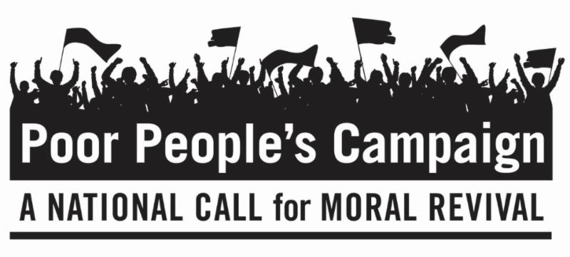
May 14, 2018
Dear Friends,
The Board of Directors, Executive Director, and all at The Interfaith Peace Project are proud to stand in solidarity with the Poor People's Campaign: A National Call for Moral Revival. This is not a partisan campaign. It is about right and wrong. It is about alleviating the suffering and indignities of people of all ages, races, orientation, religions and philosophies.
The Poor People's Campaign: A National Call for Moral Revival, is beginning a 40-day campaign on May 14, 2018. On six consecutive Mondays, people of peace are standing up for 12 Fundamental Principles at state capitals throughout the United States, including the country's capital in Washington, D.C. We are highlighting two principles on each of the six Mondays from May 14 through June 18, 2018, along with questions we developed. We invite you to be in dialogue with yourself and others about these principles.
Principle 1: We are rooted in a moral analysis based on our deepest religious and constitutional values that demand justice for all. Moral revival is necessary to save the heart and soul of our democracy.
Principle 2: We are committed to lifting and deepening the leadership of those most affected by systemic racism, poverty, the war economy, and ecological devastation and to building unity across lines of division.
Questions to Consider Personally and/or With Family, Friends and Faith Communities about Principles 1 and 2:
- Am I broken-hearted for the injustices that I see in my neighborhood? What causes me to look away?
- Do I believe that Poor People are more deeply impacted by systemic racism, poverty, the war economy, and ecological devastation? What evidence supports my belief either way?
- What would it mean to recognize Poor People’s leadership and wisdom, instead of assuming I know what is best for them and inserting myself as their leader? What does it feel like to have my authority taken away?
- How can I build unity across lines of division?
If you wish to learn more or become involved in the Poor People’s Campaign, go to https://www.poorpeoplescampaign.org/ or search for Poor Peoples Campaign in your state. Let us know where and how you will participate and send us photos and reflections.
Peacefully,
Rev. Andrea Goodman
President of the Board
with the Executive Director,
The Board of Directors,
The Advisory Board and all of us
at The Interfaith Peace Project

