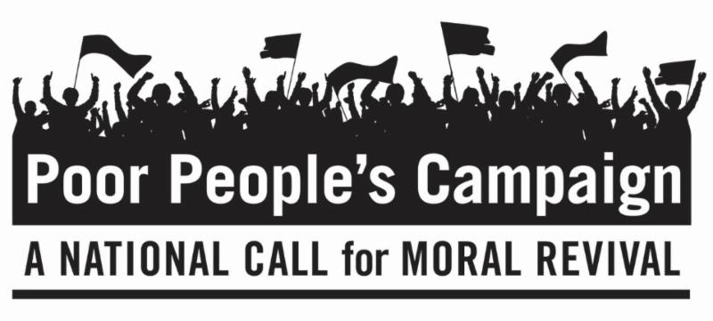
June 4, 2018
Dear Friends,
This is the fourth of six Mondays of The Poor People's Campaign: A National Call for Moral Revival that began a 40-day campaign on May 14, 2018. On six consecutive Mondays, people of peace are standing up for 12 Fundamental Principles at state capitals throughout the United States, including the country's capital in Washington, D.C. We invite you to be in dialogue with yourself and others about these principles.
Principle 7: We aim to shift the distorted moral narrative often promoted by religious extremists in the nation from issues like prayer in school, abortion, and gun rights to one that is concerned with how our society treats the poor, those on the margins, the least of these, women, LGBTQIA folks, workers, immigrants, the disabled and the sick; equality and representation under the law; and the desire for peace, love and harmony within and among nations.
Principle 8: We will build up the power of people and state-based movements to serve as a vehicle for a powerful moral movement in the country and to transform the political, economic and moral structures of our society.
Questions to Consider Personally and/or With Family, Friends and Faith Communities about Principles 7 and 8:
- How is being poor a moral issue?
- What role does my faith have when I see or think about Poor People?
- Which of these do I want to learn more about? Inequality for women. Attacks on LGBTQIA folks. Workers’ rights. The place of immigrants in our society. The disabled and the sick. Racism. We can help you explore these issues.
If you wish to learn more or become involved in the Poor People’s Campaign, go to https://www.poorpeoplescampaign.org/ or search for Poor Peoples Campaign in your state. Let us know where and how you will participate and send us photos and reflections.
Peacefully,
Rev. Andrea Goodman
President of the Board
with the Executive Director,
The Board of Directors,
The Advisory Board and all of us
at The Interfaith Peace Project

