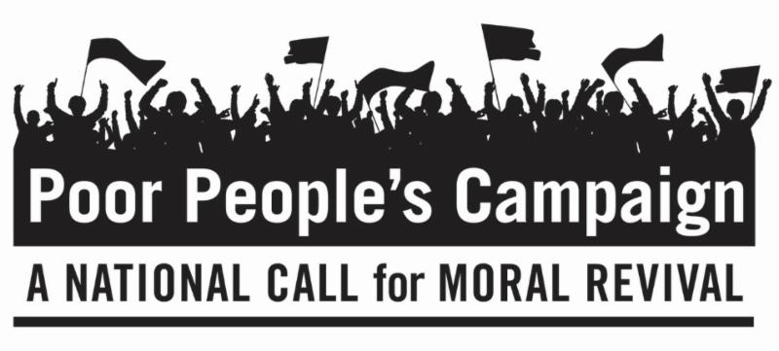
June 11, 2018
Dear Friends,
This is the fifth of six Mondays of The Poor People's Campaign: A National Call for Moral Revival that began a 40-day campaign on May 14, 2018. On six consecutive Mondays, people of peace are standing up for 12 Fundamental Principles at state capitals throughout the United States, including the country's capital in Washington, D.C. We invite you to be in dialogue with yourself and others about these principles.
Principle 9: We recognize the need to organize at the state and local level – many of the most regressive policies are being passed at the state level, and these policies will have long and lasting effect, past even executive orders. This movement is not from above but below.
Principle 10: We will do our work in a non-partisan way – no elected officials or candidates get the stage or serve on the State Organizing Committee of the Campaign. This is not about left or right, Democrat or Republican, but about right and wrong.
Questions to Consider Personally and/or With Family, Friends and Faith Communities about Principles 9 and 10:
- Who were the Poor People when I was growing up? Who are they now?
- How did I grow up thinking about Poor People?
- What is my exposure to Poor People now?
- Do I need to rethink the reasons why people of all races are Poor?
If you wish to learn more or become involved in the Poor People’s Campaign, go to https://www.poorpeoplescampaign.org/ or search for Poor Peoples Campaign in your state. Let us know where and how you will participate and send us photos and reflections.
Peacefully,
Rev. Andrea Goodman
President of the Board
with the Executive Director,
The Board of Directors,
The Advisory Board and all of us
at The Interfaith Peace Project

