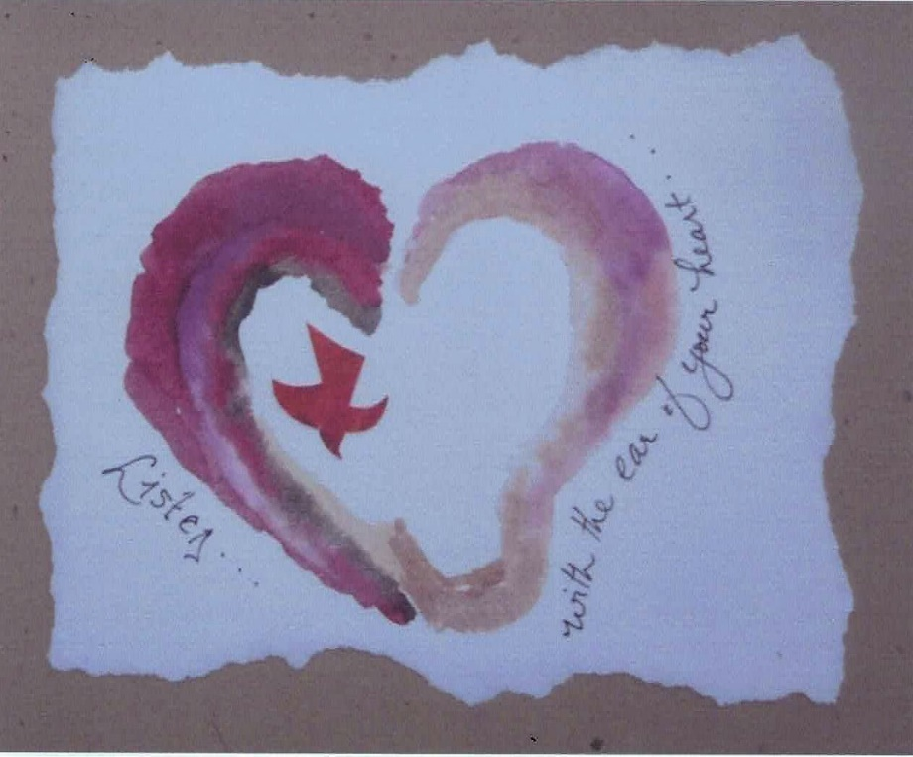

"Namaste.
I honor the place in you where the entire Universe resides.
A place of light, of love, of truth, of peace, of wisdom.
I honor the place in you where when you are in that place
and I am in that place there is only One of us."
Mahatma Gandhi

From our author, Kay Lindahl:

It is such a blessing to know that the Interfaith Peace Center is using my books for your monthly gathering in May. My message is that really listening to one another is one of the greatest gifts we have to give. It requires our full attention. It calls for a mindset of appreciation, curiosity, wonder for the other person. It is communicating from the heart. When we understand the art of listening we become aware that it is a key to communication in our global community.

I am a collector of quotes. Here are three for further reflection.

Blessings,
Kay

Here is one of the quotes sent to us by Kay. We will share the others in the next few weeks!

When Someone Deeply Listens To You

When someone deeply listens to you
it is like holding out a dented cup
you've had since childhood
and watching it fill up with
cold, fresh water.
When it balances on top of the brim,
you are understood.
When it overflows and touches your skin,
you are loved.

When someone deeply listens to you
the room where you stay
starts a new life
and the place where you wrote
your first poem
begins to glow in your mind's eye.
It is as if gold has been discovered!

When someone deeply listens to you
your bare feet are on the earth
and a beloved land that seemed distant
is now at home within you.
- John Fox

As you read the quote, what themes, words, feelings, images touched you?
What areas would you personally like to explore further?
Have you had experiences where you felt deeply listened to?
How did you feel?
How might these kinds of practices help us build better bonds of relationship with others?
How might these practices nurture a sense of community, better understanding of ourselves and others?
How might they help us reconcile conflicts and differences?

Practicing the Art of Sacred Listening
Reflection 1: Qualities of Deep Listening- Listening for Essence

"Perhaps the most precious and powerful gift we can give another person is to really listen to them, to listen with quiet, fascinated attention, with our whole being fully present.

Listening is a creative force. Something quite wonderful occurs when we are listened to fully. We expand, ideas come to life and grow, we remember who we are.

The way we listen can actually allow the other person to bring forth what is true and alive to them. Sometimes we have to do a lot of listening before the fountain is replenished. Have you ever noticed some people seem to need to talk? This is often because they have not been truly listened to. Patience is required to listen to such a person long enough for them to get to their center point of tranquility and peace.

Listening well takes time, skill, and a readiness to slow down, to let go of expectations, judgments, boredom, self-assertiveness, defensiveness."

This is just a small portion of Kay Lindahl’s book. For more information read:
The Sacred Art of Listening: Forty Reflections for Cultivating A Spiritual Practice by Kay Lindahl, published by Skylight Paths Publishing. The book is available for your use at the Antioch Center library or for purchase at your local book store.

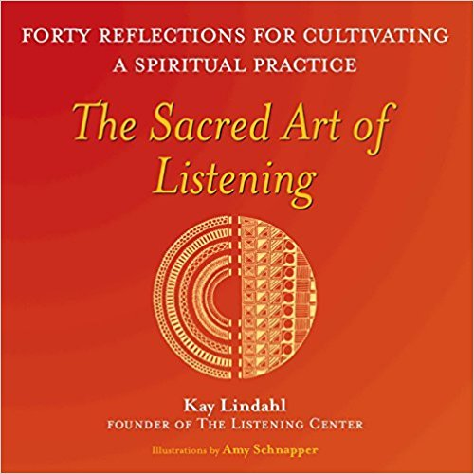

A Morning Meditation
By Randy Thomas

The first conversation we engage in everyday is the inner voice going on in our own minds. Often what we hear are ruminating words that are critical and self-judging. How can we be more mindful of these patterns and habits and find ways to change the channel of our inner dialogue to be more positive, gentle, and accepting? Our inner conversations are often the background "noise" and filter when we are trying to listen to others.

We will be offering Reflections for Cultivating a Spiritual Practice using the book, "The Sacred Art of Listening" by Kay Lindahl. These programs will take place from 12:30 to 1:30 pm at the Antioch Center on the following dates:

May 23
June 27
July 11, 25
August 8, 22
September 5, 19

The programs will be facilitated by our Advisory Board member, Randy Thomas with help from Susan Batterton. We have purchased 2 copies of the book, "The Sacred Art of Listening", and made them available for you to read at the Antioch Center. Handouts for each session will also be available along with additional supplemental resources.

For those unable to attend the programs, we will send out summaries of each program for your home study.

